OFFICER DECISION REPORT
1

ADDRESSED TO: Group Manager, Highways & Traffic
PREPARED BY: Traffic Regulation Order Team

TITLE OF REPORT: Section 106 - Ensleigh North, Bath.
PROPOSAL: Proposed variation to existing speed restrictions in and around the redevelopment of the former MOD site on Lansdown Road, Bath.
SCHEME REF No: 16-026

1. STATEMENT

The delegation to be exercised in this report is contained within Part 3, Section 4 of the Constitution under the Delegation of Functions to Officers, as follows:

Section A | The Chief Executive, Strategic Directors, Divisional Directors and Heads of Service have delegated power to take any decision falling within their area of responsibility….”
Section B | Without prejudice to the generality of this, Officers are authorised to:  serve any notices and make, amend or revoke any orders falling within his/her area of responsibility.
Section D9 | An Officer to whom a power, duty or function is delegated may nominate or authorise another Officer to exercise that power, duty or function, provided that Officer reports to or is responsible to the delegator.

For the purpose of this report, in January 2016, the Divisional Director Environmental Services delegated the power to make, amend or revoke any Orders to the Group Manager, Highways and Traffic.

2. LEGAL AUTHORITY

This proposal is made in accordance with the Road Traffic Regulation Act 1984, which under Section 1 provides, generally, for Orders to be made for the following reasons, and in the case of this report specifically for the reason(s) shown with an “x” in the right hand column:

(a) | for avoiding danger to persons or other traffic using the road or any other road or for preventing the likelihood of any such danger arising, or | x
(b) | for preventing damage to the road or to any building on or near the road, or
(c) | for facilitating the passage on the road or any other road of any class of traffic (including pedestrians), or | x
(d) | for preventing the use of the road by vehicular traffic of a kind which, or its use by vehicular traffic in a manner which, is unsuitable having regard to the existing character of the road or adjoining property,
(e) | (without prejudice to the generality of paragraph (d) above) for preserving the character of the road in a case where it is specially suitable for use by persons on horseback or on foot, or
(f) | for preserving or improving the amenities of the area through which the road runs, or
(g) | for any of the purposes specified in paragraphs (a) to (c) of subsection (1) of section 87 of the Environment Act 1995 (air quality)
3. BACKGROUND

As part of the Planning Approval for the redevelopment of the former Ministry of Defence site, the developer must amend the existing speed restrictions to accommodate the creation of a new site access point on Lansdown Road. The traffic speed along Granville Road is also being lowered to accommodate the creation of a 20mph zone within the new development.

4. ISSUES

Existing Carriageway Speeds (see Appendix 1)
The existing extents of the speed limits are shown on Appendix 1. The access to the new development will be via Granville Road (current 30mph) and Lansdown Road (currently 40mph at this location).

Proposed Carriageway Speeds (see Appendix 2)
Appendix 2 shows how the speed limits around the site are proposed to change. The existing 30mph limit is proposed to be extended northwards along Lansdown Road, past the new development, to a point between the entrances of the Kingswood School Upper Sports Fields and the side entrance to Beckford’s Tower and museum. This location would have the benefit of helping with the safety of vehicles leaving the sports fields, whilst being as visually unobtrusive as possible outside Beckford’s Tower.

There is also a bus stop near the main entrance to Beckford’s Tower, which is currently within the 50mph speed limit. The proposed changes would mean that the stop will then fall within the proposed 30mph extension, which would make it safer for vehicles to pass while the stop is in use.

The 40mph speed limit is there as buffer zone for vehicles driving from the 50mph limit to the north into the 30mph limit heading into Bath. The length of this section is proposed to remain at 250 metres, but would now start 650 metres closer to Lansdown.

The 50mph speed limit heading from Lansdown into Bath is proposed to terminate 650 metres further north than it does currently. This section of Lansdown Road appears to be a former roman road (according to sources I have found, although its name could not be confirmed), and is therefore dead straight for a long distance. Visibility for the proposed new termination of the 50mph speed limit would therefore not cause an issue.

5. SOURCE OF FINANCE

The legal, administrative and construction costs of these works are being funded out of a £31,000 contribution from the developer of the site, obtained under Section 106 of the Town and Country Planning Act 1990.
6. CONSULTATION REQUIREMENT

The proposal requires consultation with the Police, Ward Members and the Cabinet Member for Transport. If the proposal is approved, any traffic regulation Order to be made or amended will require Statutory Notification by the Council Solicitor.

7. INFORMAL CONSULTATION COMMENTS

Police:

The proposal should meet the aspirations shown in the documentation provided.

Ward Members:

Cllr Patrick Anketell-Jones:
Residents have wanted to know the new speed limits, and now I can tell them.
Cllr Anthony Clarke:
When was the TRO for the residential area signed off?

Response:
The development has been designed to be driven at 20mph (short straights, tight bends etc.), and doesn’t technically need a TRO, as it should be self-enforcing. This design was signed off by Planning (Ref: 14/01853/EFUL) on 1st April 2015.

Cllr Anthony Clarke:
As you know, the present Administration does not support 20 mph, except outside schools and other exceptional circumstances. I will not support 20 mph in Granville Road, and at most would only allow advisory 20 mph on the estate, with green roundels, and even that would require a degree of coercion.

Cabinet Member:

I will not support 20 mph in Granville Road, and at most would only allow advisory 20 mph on the estate, with green roundels, and even that would require a degree of coercion.

Response:
Following discussions with Highway Development Control, Granville Road is to stay as a 30mph road, and the entire Ensleigh North development will also have a 30mph speed limit on all of its roads (see Appendix 3).

8. RECOMMENDATION

The proposal should be approved in part, as follows:

a) The proposed changes to the 30/40/50mph speed limits on Lansdown Road should be approved.
b) The proposed change to a 20mph speed limit on Granville Road should not be approved, and should stay at 30mph.
c) The proposed 20mph speed limit on the new development site should not be approved, and should be installed as 30mph instead.

The Council Solicitor should be instructed to carry out the statutory notifications to make the Order on this basis and, subject to there being no unwithdrawn objections, the Order will be made in accordance with the drawing shown in Appendix 3.

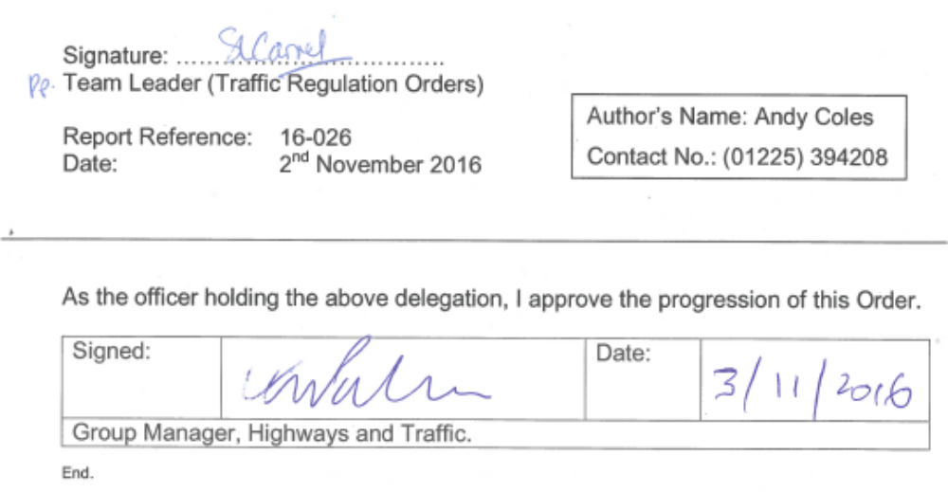

Appendix 1

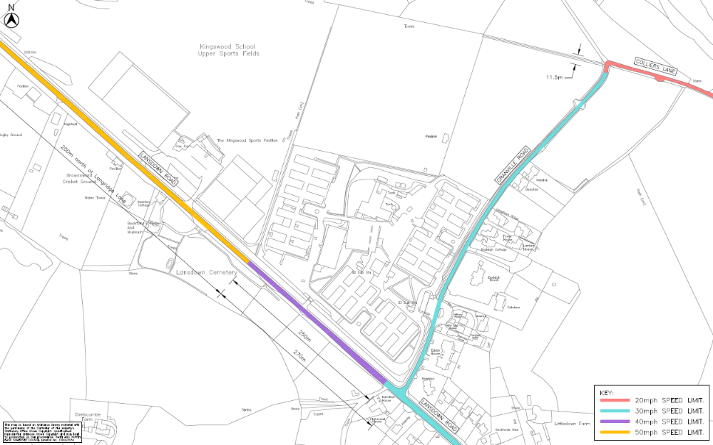

Appendix 2

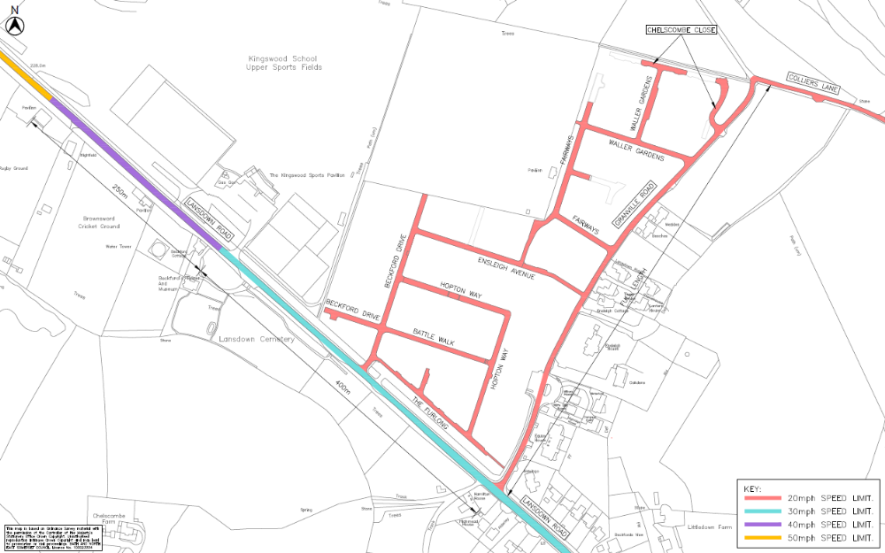
Appendix 3

